**CTF Challenge: Network Scanning - Using URLScan.io**



# **1. Introduction**

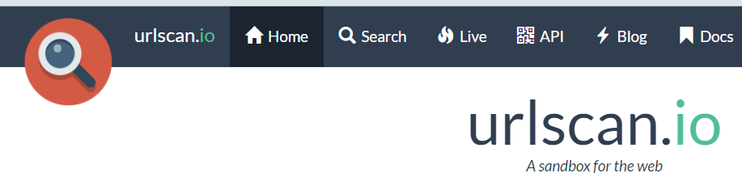

URLScan.io is an online service that scans and analyzes websites for suspicious activity, including malware and phishing attempts. This challenge will introduce you to using URLScan.io to analyze a target URL.

# **2. Tools and requirements**

Access to the internet and [**URLScan.io**](https://urlscan.io/)

# **3. Scenario**



You are an ethical hacker tasked with analyzing a target URL for suspicious activity using URLScan.io. Your job is to find the detected threats reported by URLScan.io.

# **4. Process to follow while performing CTF challenges**

* Visit URLScan.ioand Go to [**https://urlscan.io/**](https://urlscan.io/)
* Enter the target URL [**http://altoro.testfire.net/**](http://altoro.testfire.net/) into the search bar and start the scan.
* Record the detected threats from the results.

# **5. Let’s Begin the Challenge**

**Question**

Flag 1: What is the main IP Address of Altoro Website?

Answer: 65.61.137.117

Flag Captured

Flag 2: How many HTTP requests have been seen?

Answer: 10

Flag Captured

Flag 3: When was the Domain created?

Answer: July 23rd, 1999

Flag Captured

**Hint**

Use URLScan.io to perform a scan of the target URL.

